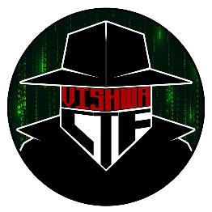

CHALLENGE NAME: [Echoes Of The Unknown]   
DEV : [Dhanashri Bodke]

CATEGORY: [Steganography]   
LEVEL: [Easy]

2025

CHALLENGE NAME: [Echoes Of The Unknown]

**Challenge Description**:

Not everything is heard—some things must be seen.

**Solution:**

In this challenge, participants were given an audio file named **file.wav**. The file contained a hidden message encoded using Morse code, but with additional obfuscation to make it difficult to extract at first glance. The key steps required to solve the challenge included:

1. **Restoring the Audio Speed** – The given audio was slowed down, making the Morse code difficult to recognize. Participants had to first adjust the speed to bring it back to its original tempo.
2. **Analyzing the Spectrogram** – The Morse code was embedded within the spectrogram view of the audio, meaning it was not directly audible. Participants needed to visualize the spectrogram to reveal the encoded dots and dashes.
3. **Decoding the Morse Code** – Once the Morse pattern was visible, they had to manually or programmatically decode it into readable text.
4. **Formatting the Flag** – The decoded text had to be converted into the required flag format by replacing spaces with underscores (_).

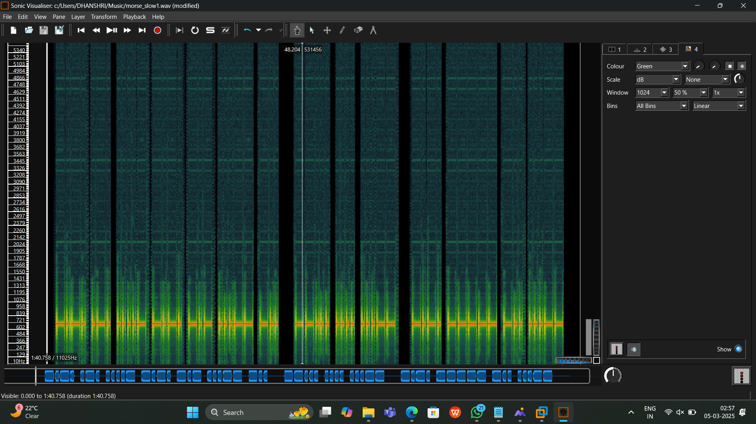

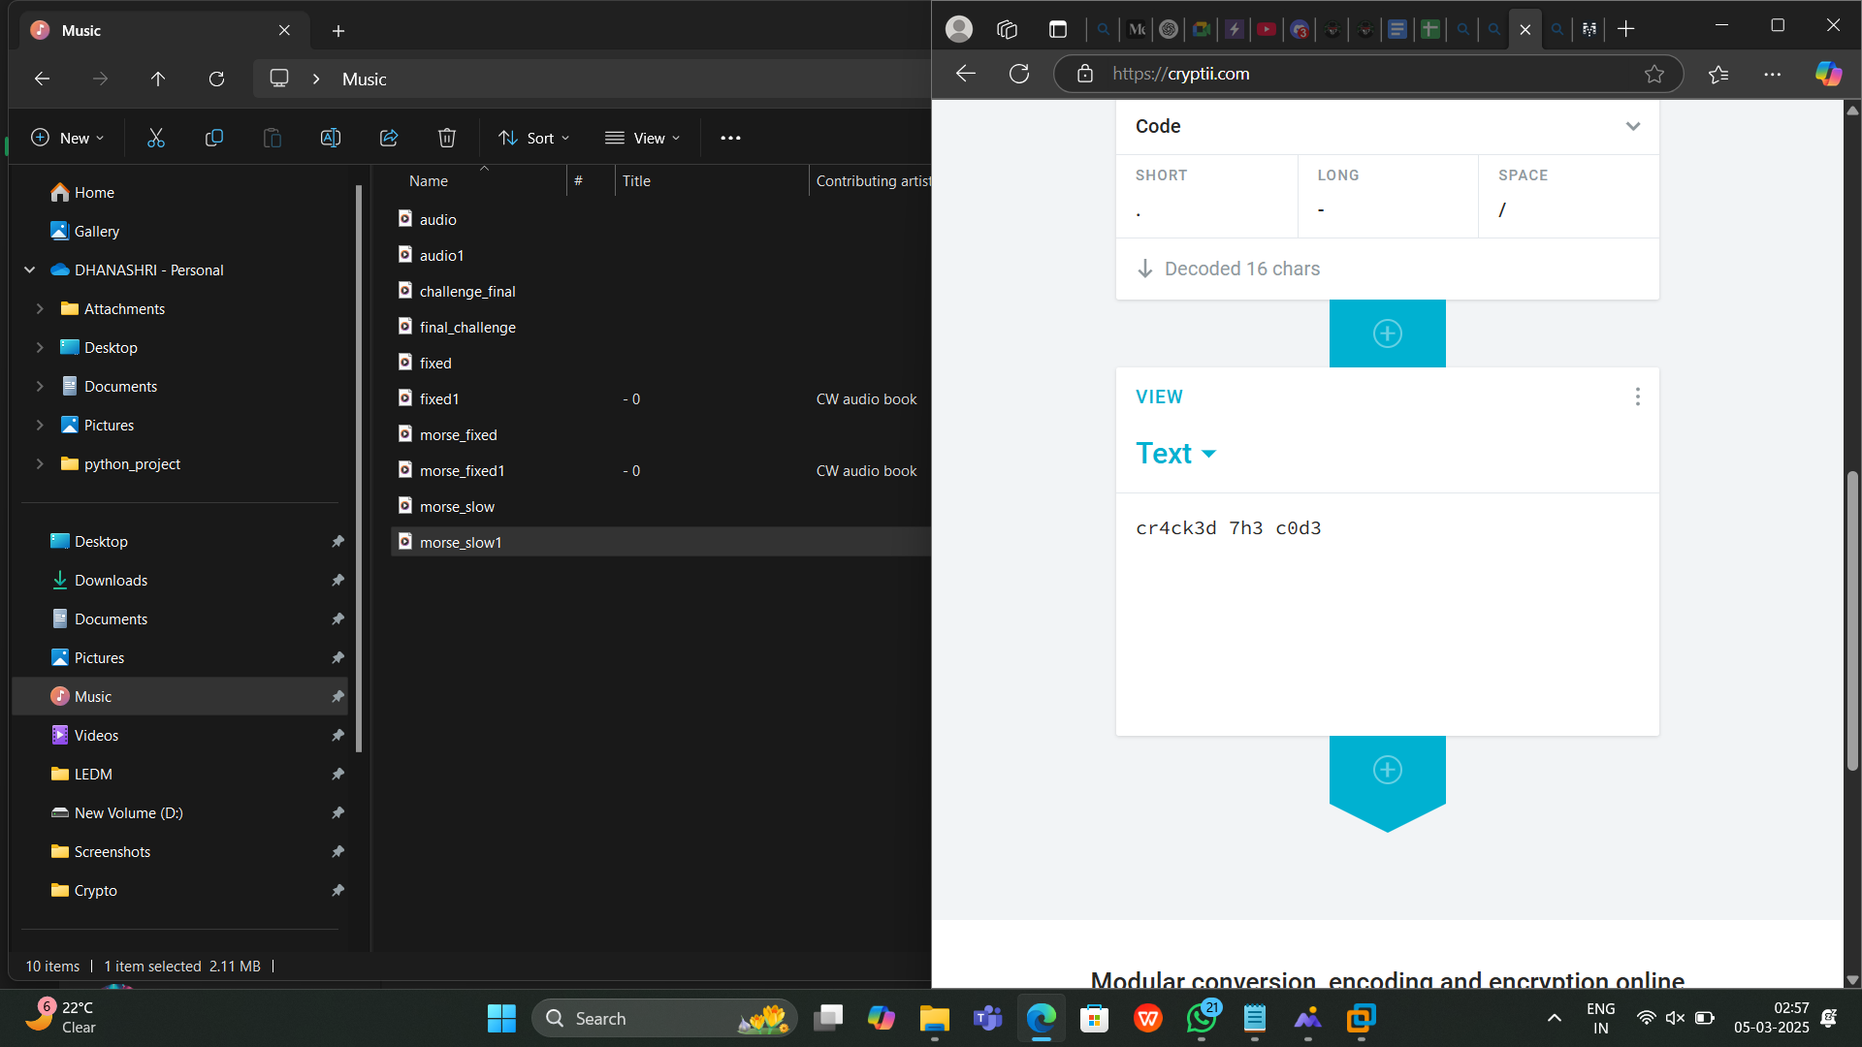

**Flag: VishwaCTF{CR4CK3D_7H3_C0D3}**

DEV : [ Dhanashri Bodke ]



DEV : [ Dhanashri Bodke ]